**ACTIVITY 3**

1. Open index.html on **Chrome**

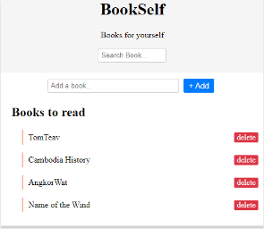

1. Open the “**Console**” tab of the developer’s tools (Ctrl + shift + I)

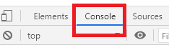

1. Execute the following instruction on console. What’s happen? Why?

document.getElementById("wrapper").textContent = "hello"

* It loads only the word “hello” on the web page.

1. Restore the HTML by refreshing the page!

Write the **instruction on console** to:

1. **Change** the **title** to: **My book list**

* Document.quertSelector(“.title”).textContent = “My book list”

1. **Change** “TomTeav” to: **Tum Teav**
2. **Change** the search bar text to :  **Type here to search**
3. **Hide** the text Books for yourself
4. **Display the title in GREEN**